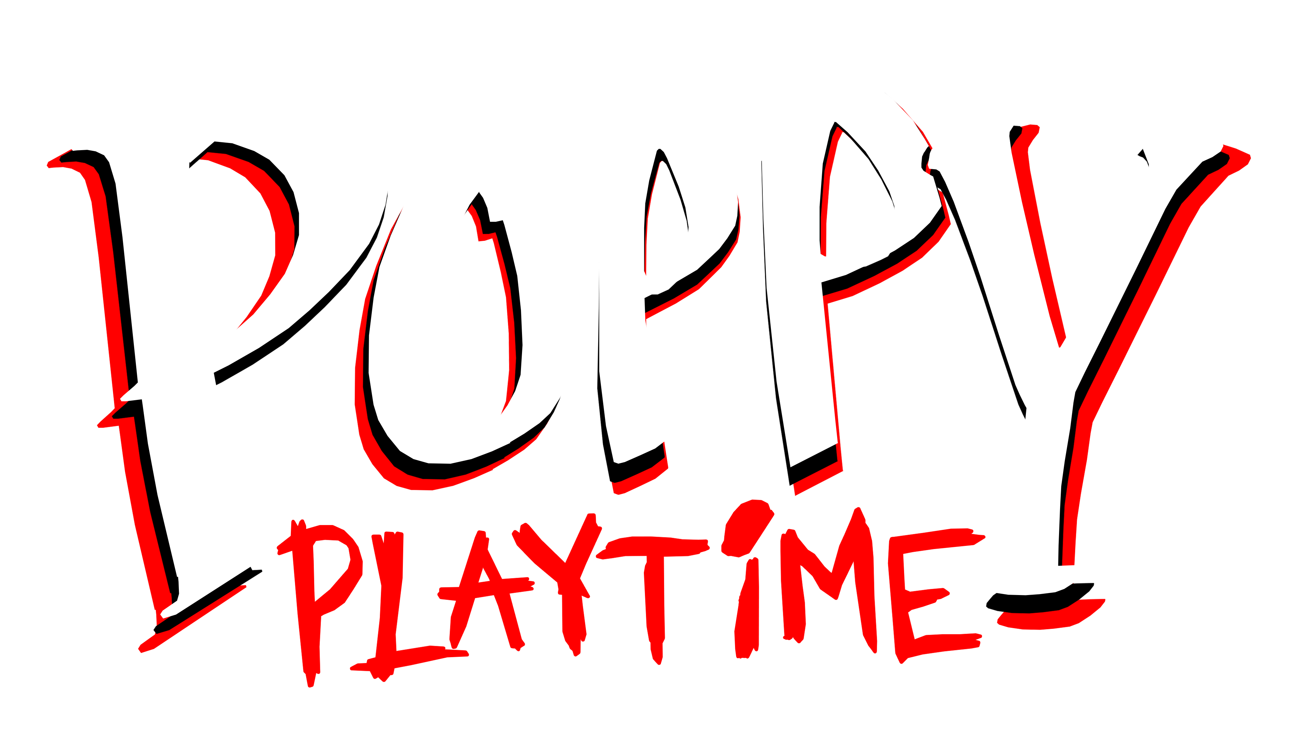
True Angel Of Salvation
What if: Angel (The Player from Poppy Playtime) chooses to save all the toys and experiments (e.g. Huggy Wuggy, Mommy Long Legs, CatNap, Doey the Doughman)
- Chapter 1: A Tight Squeeze - Angel saves Huggy from falling. Huggy is initially confused at why they chose to save him. After a moment of comfort, Angel and Huggy find Poppy.

- Chapter 2: Fly in a Web: Angel saves Mommy Long Legs from the grinder. Mommy is confused, then feels guilty for her actions. Angel comforts her, telling her that she’s not alone, and that they’ll help her. Angel can also save Bunzo Bunny, PJ Pug a Pillar, and the Mini Huggies. Huggy and Kissy reunite in this chapter. (head canon: they both suffer separation anxiety)

- Chapter 3: Deep Sleep – While venturing Playcare, Angel helps CatNap break free from The Prototype’s influence. After being saved by Angel, CatNap finally denounces The Prototype, saying that Angel is the true saviour. He then soon apologizes to DogDay and the other Smiling Critters (Bubba Bubbaphant, Bobby Bearhug, KickinChicken, Hoppy Hopscotch, PickyPiggy and CraftyCorn) who eventually embrace him, all of them crying tears of joy that they are reunited at last. (CatNap calls DogDay "sunshine", DogDay calls CatNap “moonlight"; the BBI counterparts of the Smiling Critters are still alive in this AU, Angel also can save Miss Delight and DogDay.)

- Chapter 4: Safe Haven - Angel offers emotional support to Doey the Doughman, who feels insecure about the responsibility of his role as a leader of Safe Haven. After Angel helps Doey save all the Safe Haven toys (The Mini Smiling Critters, the Mini Huggies, Medic, Scout, Odd Ed (a Mini CraftyCorn) and Izzy (a Mini Bobby Bearhug) from The Prototype, Doey soon becomes much more confident and braver, thanks to Angel's kind influence which helped him lift the weight of responsibility from his shoulders. Angel also saves Pianosaurus, Yarnaby and the Nightmare Critters (Baba Chops, Allister Gator, Rabie Baby, Icky Licky, Maggie Mako, Simon Smoke, Poe and Toullie) to offer them a second chance at life. Dr. Harley Sawyer is left confused, unable to understand why Angel chose to save all the experiments. (Cue evil cannot comprehend good moment)

Trivia

- The AU is set in the 2005 timeline of the game.
- Angel could go by they/them pronouns.
- The AU is still ongoing, given that Chapter 5 of Poppy Playtime is in the works.

- Boogie Bot, Bron, Candy Cat, Cat-Bee, Daisy, Daddy Long Legs, Baby Long Legs, and Boxy Boo are also allies of Angel.
- Ollie could be a separate character in the AU. He happens to be one of Angel's allies. In Chapters 3 and 4 of the AU, Ollie was revealed to have survived the Hour of Joy, wherein he got injured protecting Poppy; As Poppy was worried as she thought that he had died, Ollie reassured her that she and the others would be safe if the Prototype is dealt with.

